**CLOTHES LABELS**

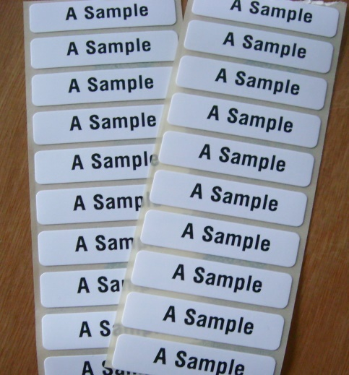**

**Iron On Sew On**

15 Name Labels £ 2.25 10 Labels £ 2.00

25 Name Labels £ 3.25 20 Labels £ 3.50

50 Name Labels £ 5.25 30 Labels £ 5.00

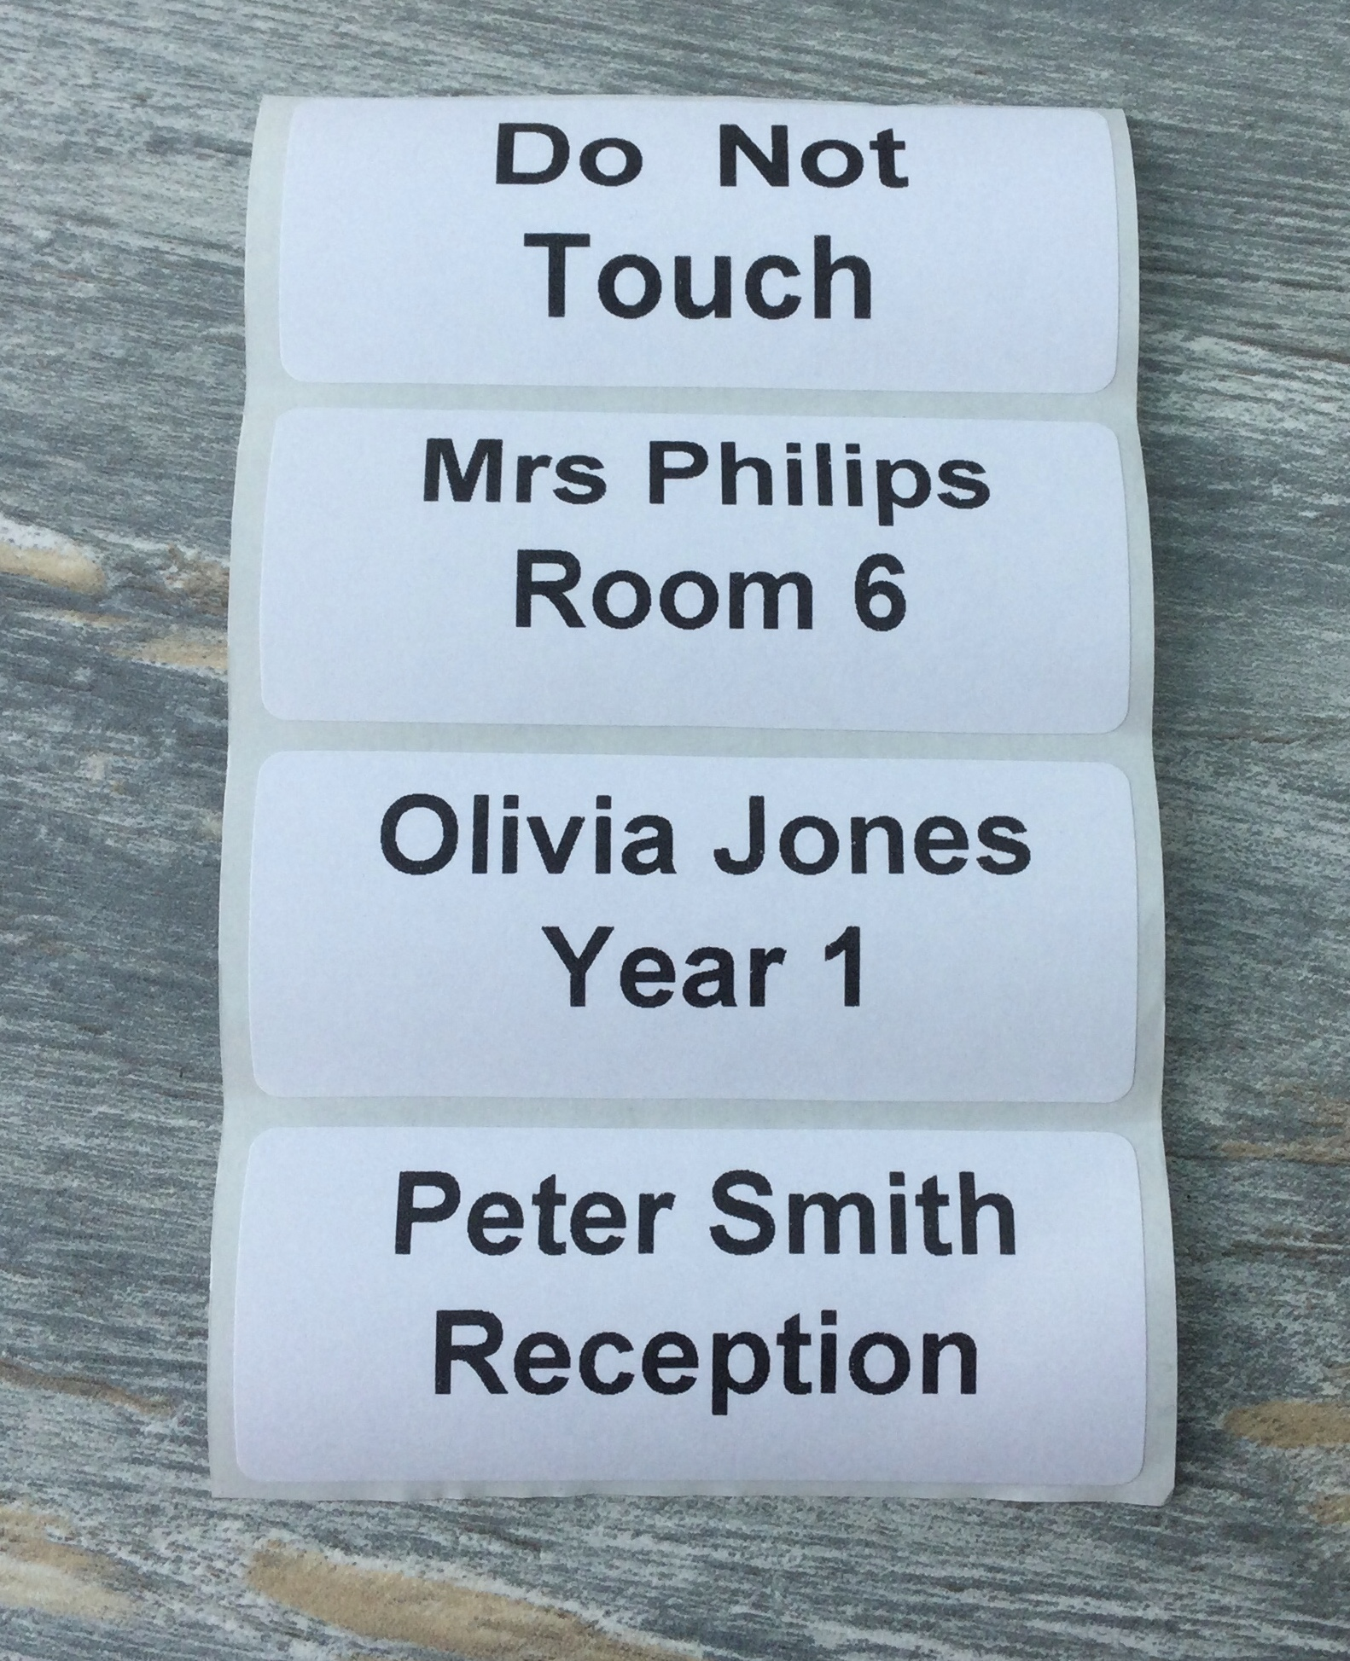 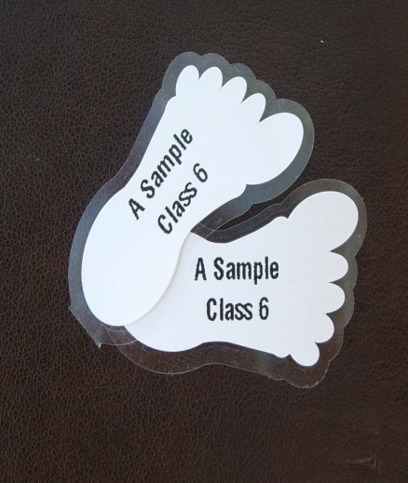

**Peel & Stick Labels** **Peel & Stick Shoe Labels**

5 Name Labels £ 1.00

10 Name Labels £ 1.75 5 pairs for £1.50

15 Name Labels £ 2.50

Order From - [www.labelcreating.co.uk](http://www.labelcreating.co.uk)

Email - [labelcreating@gmail.com](mailto:labelcreating@gmail.com)

Tel - Marion - 07754 515586